Tara Walton - tara1984 - Assn 4, solution guide

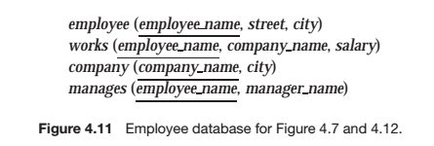

1. [20 points] Exercise 4.12 page 155.

For the database of Figure 4.11, write a query to find those employees with no manager. Note that an employee may simply have no manager listed or may have a null manager. Write your query using an outer join and then write it again using no outer join at all.

ANSWER: Tara, Tyson, Steven

1. [20 points] Assume that an employee may have more than one manager. Find names of managers who manage all the employees managed by Tyson. Notice that, these managers may manage other employees in addition to those managed by Tyson.

ANSWER: Matthew, Brent

1. [20 points] Use a **scalar subquery** (Hint: Section 3.8.7) to find the number of managers of each company. Schema of the output should be (company_name, num). Notice that, it is possible that a company may not have any managers, in which case the value 0 should be produced for num.

ANSWER: MSU – 1, First Bank – 2, Small Bank – 2

1. [10 points] Find the salary of every manager. Schema of the output should be (manager_name, manager_salary).

ANSWER: Steven 30k, Brent 52k, Matthew 30k, Tyson 40k

1. [10 points] Using a **with clause or a derived relation**, find employees who earn a higher salary than their managers.

ANSWER: Brent

1. [20 points] Exercise 3.17(b,c) page 110.

Consider the relational database of Figure 3.20. Give an expression in SQL for each of the following queries.

1. Give all managers of “First Bank Corporation” a 10 percent raise.

ANSWER: Matt $33000, Tyson $44000 updated values

1. Delete all tuples in the works relation for employees of “Small Bank Corporation”.

ANSWER: Deletes Brent, Keith